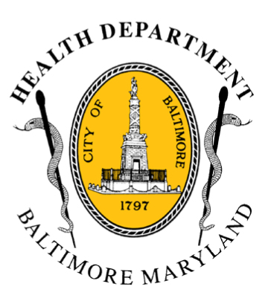
BCHD PRESS RELEASE
Baltimore City Health Department
1001 E. Fayette Street • Baltimore, Maryland 21202
Stephanie Rawlings-Blake, Mayor / Leana Wen, M.D., Commissioner of Health

FOR IMMEDIATE RELEASE

Media Contact: Michael Schwartzberg, PIO
O: (443) 984-2623 C: (443) 462-7939 E: michael.schwartzberg@baltimorecity.gov
Baltimore City Health Department Investigating Possible Measles Case
Officials believe case could be a vaccine reaction and not likely
associated with California outbreak

BALTIMORE, MD (January 24, 2015) - The Baltimore City Health Department is investigating a possible measles case in a 12-month-old Baltimore City resident. There has not been a documented case of measles in Baltimore City in the last decade; Baltimore has high vaccination rates, with nearly 99 percent of public school children being vaccinated.

“We are working very closely with local hospitals, the Maryland Department of Health and Mental Hygiene, as well as the Centers for Disease Control, to determine the specifics of the case as well as to investigate potential contacts,” said Leana Wen, M.D., Baltimore City Health Commissioner. “This is a quickly-evolving situation. BCHD staff, including the Office of Acute Communicable Diseases, epidemiologists, immunization staff and doctors, are working around the clock to gather further information about this case so that we can best protect the public and serve Baltimore.”

The patient has no travel history, including internationally or to California, or to other affected states with known measles outbreaks, has no known exposures to people who were ill, and the symptoms started after the child received the vaccine. Additionally, there are no other known reported measles cases in Baltimore.

“Based on the information we have, and out of an abundance of caution, we are treating this as a suspected measles case but it’s possible the patient could have had a reaction to the vaccine,” Dr. Wen said.

The patient presented at the MedStar Good Samaritan Hospital Emergency Department on the evening of January 21st with a high fever, rash, runny nose, cough, and watery eyes – all typical symptoms of measles (http://www.cdc.gov/measles/about/signs-symptoms.html). The patient was seen there and then subsequently, on the same night, at the Johns Hopkins Hospital Emergency Department, where they had labwork done that tested positive for the measles virus.

- more-

2-2-2

On January 2nd, the patient had received their first measles vaccine. (The Centers for Disease Control recommends all children get two doses of Measles, Mumps, Rubella (MMR) vaccine, starting with the first dose at 12 through 15 months of age, and the second dose at 4 through 6 years of age). A small percentage of people who receive the vaccine develop fever, rash, and measles-like symptoms: a reaction to the vaccine. There have not been scientifically-documented cases of patients with vaccine reactions spreading measles to other individuals.

The only way to determine if the patient has naturally-occurring measles or has a reaction from the vaccine is for a special laboratory test to “genotype”, or figure out the genetic code of the measles virus. The patient’s sample is being sent to the CDC for this testing and results are expected back late next week.

Until the laboratory results are available, BCHD officials, after consultation with the Maryland Department of Health and Mental Hygiene and CDC, are proceeding with an abundance of caution and taking measures to protect the public’s health. These include:

- The patient was placed in isolation at home following discharge from the hospital on January 21.
- BCHD staff are implementing contact-tracing measures to identify all possible patient contacts during the eight-day potential infectious period to determine if they are protected (vaccine records or history of infection).
- BCHD is working closely with involved hospitals to implement infection control protocols to identify and alert potentially affected patients and staff.

“This case may be a false alarm, and the child may not be infectious with measles,” Dr. Wen said. “However, there is an outbreak on the west coast, and measles is common in other parts of the world. We urge that parents and caregivers ensure their children are immunized. This protects themselves and everyone around them.

Measles is a highly contagious disease that is spread by coughing, sneezing, and direct contact with contaminated surfaces. More than 90 percent of individuals who are in close contact with an infected person and who are not vaccinated will get the disease.

Prior to the measles vaccine in the 1960s, nearly every school-age child contracted measles. Several hundred people in the United States died every year from it, and thousands suffered long-term damage such as hearing loss and brain damage.

Worldwide, measles is prevalent in multiple countries—nearly a million children across the world die from measles. In the United States, measles was considered eradicated in 2000, when there were just a few dozen cases. However, due to parents receiving misinformation and choosing not to vaccinate their kids, the incidence of measles has been rising. There were 644 cases of measles in the United States in 2014.

###

